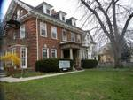

The Toronto Monthly Meeting of the Religious Society of Friends (Quakers)

60 Lowther Avenue, Toronto, Ontario, M5R 1C7

Quaker Committee for Refugees

Annual Report 2016

The Conservative government brought in many policies which made life difficult for inland asylum seekers and even for those trying to get to Canada from abroad. It is under these circumstances that the work of the refugee committee in Toronto continues to be relevant as we provide services to those who come to our doors seeking assistance. During the year 2016, with the advent of a new Liberal Government we were trying to catch up with many government announcements and proposed changes in regulations. These proposals mark the beginning of a new era on immigration matters. Amongst these changes were some of the following:

Promising to double the number of immigration applications allowed for parents and grandparents.

Making it easier for international students to achieve Canadian Citizenship.

Bypassing the two year wait period for “Conditional Permanent Residence” for spouses of sponsored individuals.

Restoring the maximum age of dependants from 19 to 22.

Making it easier for parents to bring their older children to Canada.

Doubling the budget for processing family class.

Bringing more Syrian refugees to Canada.

Restoring free access to healthcare for refugees.

We were busier than previous years not just because we were providing services to the community but also because we were trying to catch up with government announcements and proposed changes in regulations. We participated actively in local, provincial and national networks such as the Toronto Refugee Affairs Council (TRAC), the Coalition of Service Providers for Refugee Claimants in Southern Ontario, the Ontario Council of Agencies Serving Immigrants (OCASI) and the Canadian Council for Refugees (CCR). Our participation in all these networks aimed at keeping ourselves vigilant to make sure that as a society we kept our doors open to those who need safe haven, while at the same time making sure we support those already here who are in need of assistance.

The needs of displaced persons and refugees has long been part of Friends’ work, which started in England and has continued in Toronto through the work and support of former and present committee members, Toronto Monthly Meeting (TMM), and Quaker foundations that have unconditionally help us out. The committee has gone from assisting Central Americans to serving people from all parts of the world. Our specific aim is to provide assistance to refugees both during and after the application process in the areas of translation and interpretation, application to social services, finding shelter on arrival, obtaining legal aid services, inland and overseas family sponsorship applications, detention related matters, medical and school appointments and other settlement services. In addition our committee members spend a lot of their time speaking to local and national politicians, and creating awareness of refugee issues within the Quaker community and the community at large. We all work together and dream of the days when Canada gets back to playing a leading role in refugee protection in the world.

Nancy Pocock began the Refugee work in the Meeting, starting with helping Vietnamese refugees and later on Salvadorans. I was one of those she helped; I started working with her on a part time basis. Fred Franklin and Erika Whitney had been part of that early effort. It has been my privilege to be part of this work and organization for over a quarter of a century. When Nancy Pocock died in 1998 John Pendergrast became Clerk of the Committee, followed by Raja Rajagopal and then Brydon Gombay. The legacy and their struggle for the people continue in our work and commitment to represent and aid refugees and new immigrants seeking protection and their human rights. The work of the Committee is a witness of the Toronto Friends and is a continuing Concern of the Monthly Meeting. The present Clerks are Judy Pocock and Eleanor Andrew.

The tables below provide some statistical and demographic information about the people who have received assistance from our office at Friends House in Toronto.
Table A  Nationality of People served | Table B  Types of Services provided to Refugees at Friends House
Afghanistan 7  Albania 1  Angola 7  Argentina 4  Bangladesh 7  Bahamas 1  Bolivia 4  Cameroon 5  Colombia 33  Costa Rica 6  Chad 3  Chile 9  China 9  Dominican Republic 13  Ecuador 11  El Salvador 19  Eritrea 5  Gambia 5  Ghana 3  Guatemala 15  Guyana 7  Grenada 8  Honduras 17  Iran 7  Iraq 7  Israel 3  Ivory Coast 5  Mexico 32  Namibia 5  Nicaragua 10  Pakistan 5  Paraguay 5  Peru 7  Syria 5  Sierra Leone 5  Somalia 6  Sudan 7  Sri Lanka 4  St. Vincent 5  Total 317 | Application forms 152  Basis of Claim Form (BOC) 19  Food & Transportation 2  Furniture Bank Appointments 15  Christmas Party Intake Forms 56  Income taxes 4  Letters 39  Long term housing 11  Oral Interpretation (Lawyer’s office) 39  Translation of documents 60  Referrals 137  Short term housing (shelters) 23  Telephone calls 1,490  Grand Total 2,047  Table C  Immigration Status of People Assisted  Convention refugees 54  Caregivers 6  Failed refugee claimants 75  Landed immigrants 91  Persons without status 13  Refugee claimants 55  Temporary residents (Students, temporary workers and visitors) 23  Total 317

REFUGEE ART SHOW
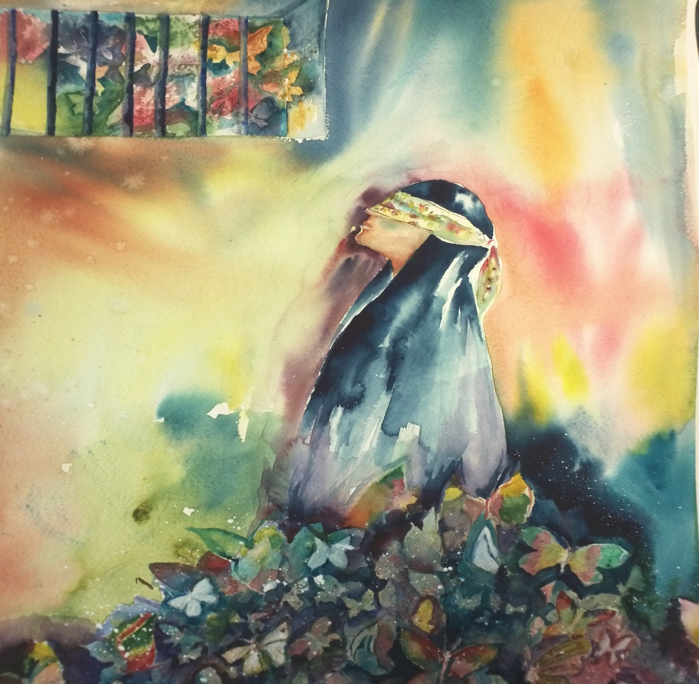
In Hope for Being Butterflies, a self-portrait of Iranian artist as a prisoner.

Beyond Fear and Loss, Reaching for Hope.
As part of the Refugee Rights Month Celebration, the Quaker Committee for Refugees held a two days exhibition to showcase the work of artists who have found refuge in Canada, along with artwork of those born here who support the rights of refugees and their inclusion in our multicultural society, in an exhibition of sculpture, photography, painting and mixed media and textiles. This painting is a donation to the Refugee Committee by John Gell, and Michael and Ruth Malloy, the artist wishes to remain anonymous because of her family in Iran. Thanks to Helen Melbourne for her support as an artist, curator and organizer of this amazing event.
The Importance of our Presence at the Immigration Holding Centre
As I helped Ahmed (Not his real name) a very talkative teenager from Syria get legal representation to be allowed to stay in Canada I discovered that he had tried to make a refugee claim at the Fort Erie border as an unaccompanied minor but was instead put in isolation at the Immigration Holding Centre. It was shocking to see a kid from Syria, the very country from which Canada has decided to take 25,000 refugees for resettlement, being ordered deported, not being allowed to contact his family and to even socialize with the rest of the detainee population. There was no reason to detain him as he was not considered to be a danger to the public, furthermore , detention for children is supposed to be a last resort. Now here he was; sitting across the table from me trying to understand what was happening to him. He began telling me that he has been living in Egypt with his family where his residency permit had expired. He was facing being sent back to Syria where he would be most likely recruited into the army. Fearing the worst his parents decided that the best place for him to flee was Canada. As a representative of TRAC I connected him with a lawyer who helped Ahmed to get started with an immigration process that not only delayed his deportation but ended up getting him released from the Holding Centre after being granted first –stage approval for permanent residence on Humanitarian & Compassionate grounds by the Minister of Immigration John McCallum.

Ahmed never thought upon his arrival to Canada that he would experience having his belongings removed, being put three weeks in detention with the threat of imminent removal from Canada. He had already suffered war in his country fleeing under dangerous conditions to another country, the threat of being deported back to a war- torn country and then being sent to Canada, a child by himself separated from his family and everything that he ever knew. Then he would again face more fear and uncertainty. It is during this time of re-traumatisation that he had to justify that he was a refugee, a victim of a horrific war and plead for protection. This story has a happy ending most probably because the government decided to act to help the Syrian people who were suffering from tragedy and war in 2015. The action started when then two children of a Syrian refugee drowned while trying to cross the sea to safety in the Mediterranean. The children were younger then Ahmed, but they were children just the same. For any child to endure what Ahmed went through it is to repeat a tragedy. Now the Syrian war is in the forefront of news every day.

There are many other human beings facing long periods of detention dealing with ID issues and detention reviews, refugee hearings, and interviews all the time. It is for this reason that the issue of detention is at the heart of the work of the Quaker Committee for Refugees in Toronto. We are unique in the sense that we are one of the few community agencies allowed to enter the detention facility at 385 Rexdale Blvd in Toronto, thanks in part to all the hard work of Fred Franklin and Eusebio Garcia in maintaining good relations with the staff at the holding centre. Ahmed's story is like that of many people in detention and thanks to God has a happy ending. He has been allowed to have freedom, safety and peace that he deserves in Canada. Many others like Ahmed and his family are in need of our support and we will continue the struggle to help our fellow human beings.
The number of people served at the immigration holding centre in 2016 by the staff at the TRAC office reflects only a small portion of the people detained. These numbers and their nationalities always seem to fluctuate although they are given here to provide an idea of the nationalities of the population of detainees who seek orientation at the TRAC office.

Table D.
People Served at the Holding Centre
Afghanistan 4  Antigua 4  Bangladesh 5  Barbados 13  Burkina Faso 5  Burundi 5  Brazil 4  Cameron 4  Chad 5  China 22  Colombia 5  Costa Rica 3  Chile 7  Dominican Republic 3  Denmark 1  Djibouti 2  Ecuador 3  El Salvador 5  Egypt 4  Eritrea 4  Ethiopia 5  France 1  Georgia 3  Ghana 7  Grenada 8  Greece 2  Guatemala 7  Guyana 3  Guinea 3  Honduras 11  Hungary 15  India +18  Iran 8  Iraq 11  Israel 5  Italy 1 | Ivory Coast 3  Jamaica 32  Jordan 5  Kenya 8  Kosovo 3  Kuwait 1  Libya 5  Lithuania 1  Mexico 31  Morocco 8  Nicaragua 9  Nigeria 25  Namibia 8  Netherlands 1  Palestine 4  Pakistan 15  Peru 11  Portugal 3  Philippines 8  Poland 3  Russia 3  Rwanda 5  Saudi Arabia 4  Senegal 4  Serbia 1  South Korea 2  Somalia 6  Sri Lanka 11  Stateless 1  St. Lucia 11  St. Vincent 12  Spain 5  Syria 4  Tanzania 9  Trinidad 11  Uganda 5  Ukraine 2 | United Arab Emirates 3  United States 2  United Kingdom 2  Uruguay 7  Venezuela 7  Vietnam 7  Yemen 3  Total 527  Table E  Number of people by immigrant status  Live-in caregivers * 6  Failed Refused claimants 226  Safe Third Country detained (Not eligible to make a claim in Canada) 6  Sponsorship breakdowns 7  Overstayed farm workers 19  Overstayed student visas 18  Overstayed visitors 52  Visitors (held on suspicion) 108  Withdrawal of Claim 15  Refugee claimants 70  Total 527

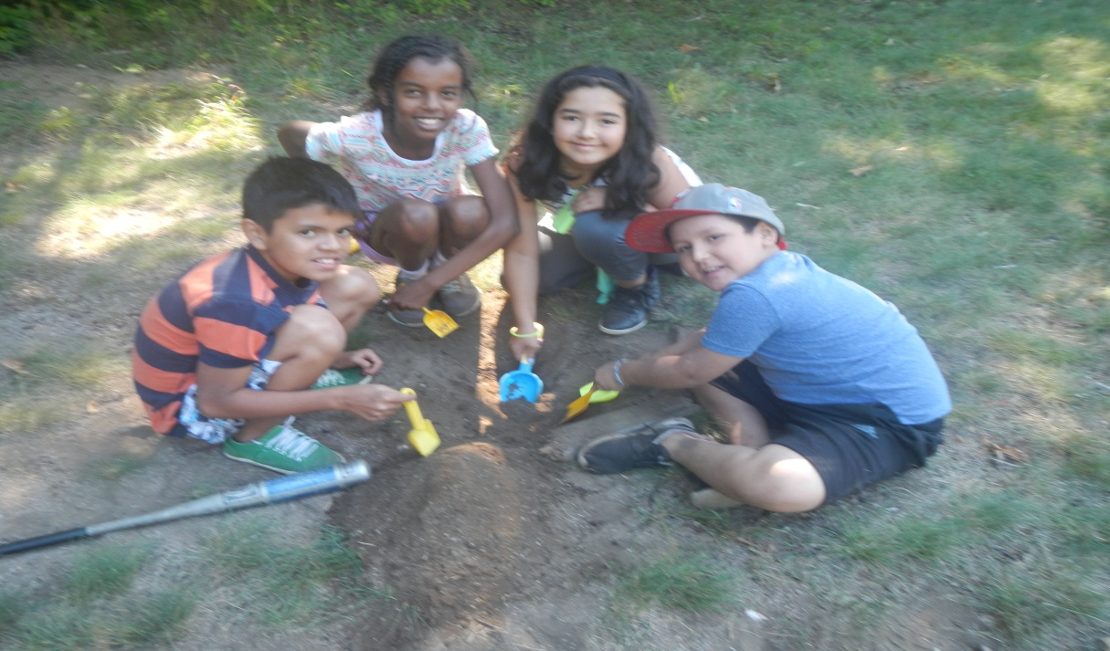
Refugee Weekend at Camp Nee-kau-nis
Camp Nee-Kau-Nis followed its Labour Day Weekend tradition of hosting a Refugee Camp for both recent and former refugees. The Camp brings together recent refugees, most of them young and often culturally disoriented, with former refugees, now successfully established in Canada, and ideally suited to act as mentors. This data for this year's camp, is remarkably like last year’s: number of campers – 80; age range - 11 months - 75, with several families having multiple young children, first time in Canada - 6 weeks to several years; countries of origin: Argentina, Armenia, Colombia, Egypt, El Salvador, Eritrea, Ethiopia, Guatemala, Iran, Iraq, Mexico, Nicaragua, Nigeria, Paraguay, Peru, Rwanda, South Sudan, Uganda, Uruguay.
Refugee Weekend offers opportunities to expand friendships and to create new ones; it provides support, respite and relaxation; and it allows those who are sometimes overwhelmed by the whole process of being refugees, to meet others who have successfully passed through that same process and built homes and lives in Canada.
We are very grateful to the Camp committee for allowing us to use the facilities and to our directors Ken and Rae Mavor for their unconditional support and guidance and for making every single person at the camp feel welcome at all times. Special thanks to the Salvadoran Canadian Association of Toronto (ASALCA) and to Future Watch for their assistance with the logistics and organization of this special event.

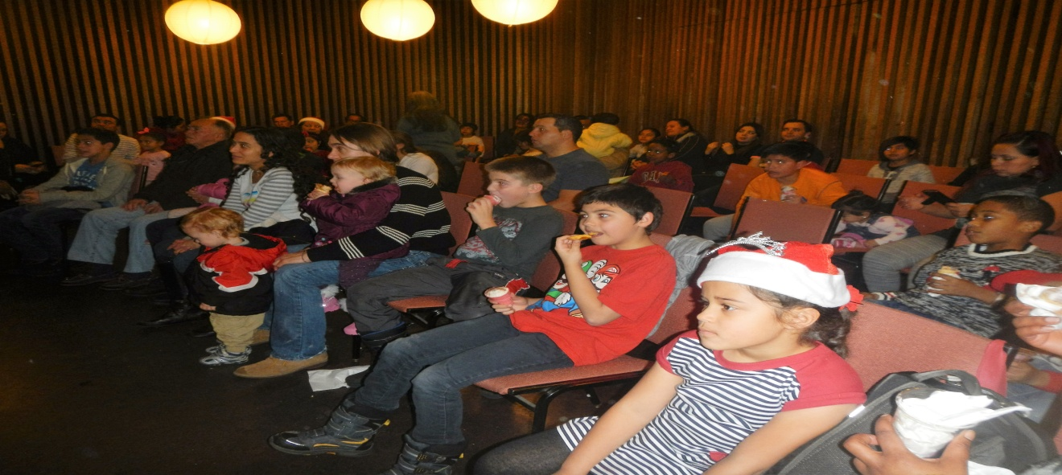

Christmas Party

Within a few hours of announcing over the phone that we are taking names for the refugee children Christmas party floods of phone calls come into the refugee office at the Quaker House, it is kind of funny because the list is full in no time and the process of registration starts with CHUM Christmas Wish. More than a hundred children and their parents register and get accepted every year and attend this special activity where committee members and other volunteers make them feel welcome in their new country. The party has been a celebration of the Quaker Refugee Committee for the last twenty-seven years and a wonderful way to make a difference for newcomers during the holiday season. We had the privilege of being entertained by Judy Pocock’s story of the little Jesus as a refugee relating the reality of those days to the present climate of the refugee population. We also had the opportunity to enjoy the performance of talented children who sang, played the piano and the guitar for the attendees. Together they produced the much needed entertainment for the festive season. Of course Santa joined us to spread cheer and deliver a present to each child, beautifully wrapped with care by committee volunteers and ASALCA friends of our work. At the conclusion of our Christmas party the children and the adults alike were happy, fed, and entertained. They carried their gifts to open on Christmas Eve, as is traditional in many of the countries from which they come. We, all the volunteers, are also left with a sense of great accomplishment and a desire that despite big challenges facing them in the future, things for the children and their families will continue to get better.

Many thanks to all the volunteers and CHUM Christmas Wish for providing the financial funds and toys for more than a hundred children and their parents who attended the party.

Thank you
The Quaker Committee for Refugees continues with our mandate to serve the needs of the refugees and new immigrants so they can integrate and participate in Canadian society. Our ability to assist the number of people mentioned earlier in this report would not have been possible without the assistance and support of many individuals and organizations. Among our recent donors are:

Annapolis Valley Monthly Meeting
Canadian Friends Service Committee (CFSC)
CHUM Charitable Foundation
Kitchener Area Monthly Meeting
Nancy’s Very Own Foundation
Samuel Rogers Memorial Trust
Many generous individuals.

Our finances are administered by the Treasurer of Toronto Monthly Meeting (TMM), whom we thank for this service. All donations to the QCR are spent on the work of the committee, which is required to raise these funds to pay for all its expenses. As a concern of the TMM (Quakers), the Refugee Committee is a federally approved charitable organization (#11926-6955-RR0001). We welcome contributions, which may be made out to Toronto Monthly Meeting, with Quaker Committee for Refugees in the Memo line and mailed to: 60 Lowther Avenue, Toronto, Ontario, M5R 1C7.

We are also into our sixth year of an initiative which has taken us back to our roots, through jewellery designed by Nancy Pocock, whose work on such designs was gradually taken over by the work for refugees which came to absorb her life, from the time when refugees from Vietnam first arrived on our shores. Her daughter Judy, a member of our committee, has found some of her mother’s designs of provincial floral emblems, and one of a maple leaf, and has arranged to have them made up as silver pendants or a maple leaf pin, to be sold to benefit the work of our committee. Anyone wishing to know more about Nancy’s Jewellery Project can reach her by email: judy.pocock@utoronto.ca.
We would like to thank Sarah Hall for her generous contribution of Cards by her own design which have been donated to the QCR to be sold and all proceeds to benefit the QCR.

As always we are also grateful to Toronto Monthly Meeting, Secretary Asst. Treasurer Linda Stemmler and Resident Friends, Ben Bootsma & Judith Amundson for supporting our work in so many ways.

Members of the refugee committee this year were Judy Pocock, Eleanor Andrew, June Pollard, Margaret Gail Funston, Rosemary Meier, Ann Buttrick, Brydon Gombay, Sarah Hall, Ebby Madera, Frank Showler, Charlie Diamond and Eusebio Garcia.

