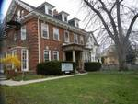

Quaker Committee for Refugees
Annual Report 2019

The Toronto Monthly Meeting of the Religious Society of Friends (Quakers)

Introduction
The first quarter of 2019 I participated in several meetings with the local Coalition of Agencies Serving Immigrants of Southern Ontario with the objective of getting informed about what they were doing, but also to strategize on ways to deal with the Ontario’s cuts to legal aid for refugee claimants. We were all very concerned because the cuts meant that legal aid would honour certificates for Basis of Claim form preparation, but not for Immigration &Refugee Board hearings. The announced cuts were to begin in April and the NGO sector was very concerned as the budget cuts meant claimants were now left to navigate a complex refugee legal system on their own and without legal representation and therefore their access to justice was limited. Local, provincial and national civil society networks made a lot of noise about the negative effects of such cuts without success as the Ontario government ended up cutting these vital services despite our objections. Fortunately in August the federal government announced that they would fill the funding gap made by Ontario’s cuts to legal aid. The announcement was a huge relief not just for those who really needed representation in court but also for all the agencies like ours who have no means to provide such valuable services to those seeking protection.
Omar (not his really name) was an example of those in the list of those affected by the legal aid cuts. He was a citizen of Somalia who joined politics in February 2018 when he was elected a leader of a local clan as there is no party system in Somalia. Every village or community selects one man to represent them in Mogadishu. The lives of Omar and his family were in danger when Omar was targeted by a terrorist group known as Al Shabab. Al Shabab’s agenda is to rule Somalia, using the Islamic Sharia Law while demolishing the State’s constitution. This group was against Omar’s political opinions. They were also against institutions of development such as school, community centres, hospitals and libraries to mention some. They considered these institutions anti Islamic. By contrast, Omar believes in liberty and equal opportunities for men and women; he would emphasise the importance of higher education, and an overall legal system rooted in the state’s constitution. Omar would also push for respecting the diversity of the Somali nation by respecting other religious beliefs present in the country. The threats were triggered in December 2018 when Omar openly criticized Al Shabab on a local radio station. He told them that he was against their terrorist activities, which included torturing people, cutting off the hands of those who steal, and even shaving the heads of those who style their hair. From this date on, Omar started receiving death threats in the form of phone calls in which they said that they would kill the entire family. In the same year a friend of Omar was also targeted by Al Shabab and killed. Omar decided to leave Somalia when he realized that he was unable to get enough support and protection, due to the clan being a minority with a few people in power available to help. Contacting the police was also a waste of time, because of the weak legal system and its lack of resources. Omar arranged his departure from Somalia in January 2019, using a false passport which helped him to get to Toronto, where he made a refugee claim. Fortunately for Omar, Legal Aid issued him a certificate for a hearing representation in September, and was also able to enrol him in a mock Refugee Hearing Program at Matthew House, a local shelter which works resettling newly arrived refugee claimants who would otherwise be homeless. Omar is now a Convention refugee and has applied for permanent resident status. The cuts to Legal Aid by the provincial government continue, but thanks to the influx of money from the federal government many other refugee claimants have been granted positive decisions and are now a few years away from becoming Canadian citizens.

The tables below provide some statistical and demographic information about the people who have received assistance from our office at Friends House in Toronto.
Table A  Nationality of People served | Table B  Types of Services provided to Refugees at Friends House
Afghanistan 3  Albania 1  Angola 3  Argentina 10  Bolivia 4  Cameroon 2  Colombia 32  Costa Rica 3  Cuba 6  Chile 5  Djibouti 1  Dominican Republic 7  Ecuador 13  El Salvador 21  Eritrea 3  Gambia 1  Ghana 1  Guatemala 11  Guyana 8  Grenada 3  Honduras 21  Iran 7  Iraq 1  Israel 1  Ivory Coast 1  Jamaica 4  Mexico 37  Namibia 3  Nicaragua 17  Nigeria 2  Pakistan 5  Paraguay 7  Peru 12  Syria 8  Sierra Leone 2  Somalia 10  Sudan 3  St. Vincent 4  Venezuela 21  Total 304 | Application forms 167  Basis of Claim Form (BOC) 13  Food & Transportation 1  Furniture Bank Appointments 8  Christmas Party Intake Forms 58  Income taxes 7  Letters 25  Long term housing 7  Oral Interpretation (Lawyer’s office) 39  Translation of documents 79  Referrals 125  Short term housing (shelters) 11  Telephone calls 1,380  Grand Total 1920  Table C  Immigration Status of People Assisted  Convention refugees 58  Caregivers 2  Failed refugee claimants 55  Landed immigrants 101  Persons without status 10  Refugee claimants 55  Temporary residents (Students, temporary workers and visitors) 23  Total 304

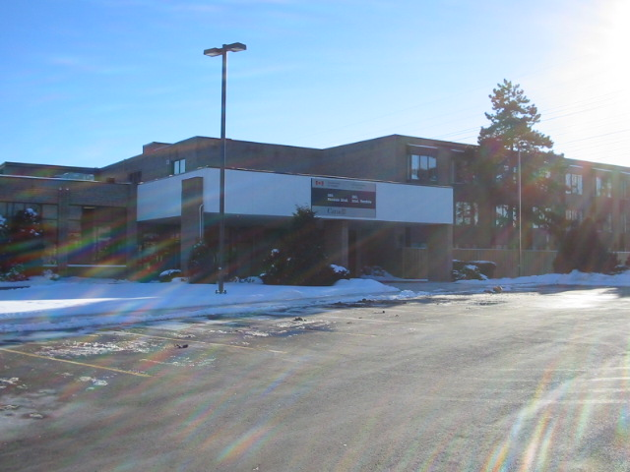
TORONTO IMMIGRATION HOLDING CENTRE:
I have been visiting the Immigration Holding Centre (IHC) for at least 22 years, first at the old building on Airport Rd near Pearson Airport and later at the new location
on Rexdale Blvd. Both locations have the capacity of housing over a hundred people at
any given time. The Government of Canada has always used these facilities to almost full capacity. The structural changes in the last three years would make you believe
that the number of people in detention would increase, but in 2019 the opposite
happened. The number of detainees at any given time was fewer than fifty people, and
no children were detained. We believe that this change is in part due to the new
National Immigration Framework in which the Canadian Border Security Agency
(CBSA) is already seeking, along with other stakeholders, for more alternatives to
detention. It also has to do with the fact that detainees have access to legal
representation for their 48 hour detention review through the Refugee Law Office. In
many instances officers are willing to let people go with a bond before their 48 hour
detention review. Such is the case of Frank (not his real name). His wife, a Canadian
citizen, phoned me on a Monday evening in December asking for help. She said that her husband had been stopped by the police while driving, they found out that there was an immigration warrant against him, and arrested him immediately. She was so nervous and did not know where the police had taken her husband. My reaction that night was to stay by the phone and wait until he called and informed her of his whereabouts. Sure enough, she phoned me early on the morning of the following day to let me know that Frank had been transferred to the Immigration Holding Centre. I then phoned my CBSA Liaison officer at the Holding Centre and the lawyer on site that day, leaving a message for both of them explaining Frank’s situation. An hour later I received a phone call from the lawyer asking me to phone and ask Frank’s wife to be at the IHC by 11: 00 am to pay a bond for the release of her husband. To make a long story short, after his release I assisted Frank’s wife to submit a Pre-Removal Risk Assessment application, and a sponsorship application, along with a Work Permit application. We are hopeful that Frank will eventually be granted permanent resident status in Canada and that he and his wife, to whom he has been married for the last ten years, can finally have a normal life. Not everyone is as lucky as Frank but there are times when things happen at the right moment, as well as the fact that we, through our TRAC network, have managed to establish and continue a good relationship with the Canada Border Service Agency.
The tables below reflect the services provided to a portion of the population at the Immigration Holding Centre. They also give a sense of peoples’ nationalities, and immigration status. Our presence at the detention center provides a link between detainees and outside community agencies such as the Refugee Law Office, Legal Aid Ontario, Romero House and Sojourn House.
Table D.
People Served at the Holding Centre
Afghanistan 9  Antigua 1  Argentina 2  Bangladesh 1  Barbados 3  Belgium 1  Bulgaria 1  Burkina Faso 1  Brazil 5  Britain 2  Cameroon 4  China 19  Chile 1  Colombia 13  Congo 1  Cuba 7  Croatia 1  Czech Republic 1  Dominican Republic 4  Djibouti 1  Egypt 1  El Salvador 2  Eritrea 1 | Ethiopia 3  Gambia 8  Ghana 3  Greece 1  Grenada 1  Haiti 1  Guatemala 7  Guinea 3  Guyana 1  Haiti 2  Honduras 3  Hungary 2  India 15  Italy 1  Ireland 1  Iran 8  Iraq 4  Israel 1  Jamaica 13  Korea 7  Libya 1  Lithuania 1  Mexico 35  Nigeria 38 | Pakistan 13  Philippines 2  Poland 1  Portugal 8  Rwanda 1  Rumania 2  Saudi Arabia 4  Somalia 20  Slovakia 1  Sri Lanka 12  St. Lucia 17  St. Vincent 17  Sweden 1  Taiwan 1  Tanzania 1  Turkey 4  Trinidad 3  Uganda 4  Ukraine 6  United States 11  Vietnam 5  West Sahara 1  Zimbabwe 2  Total 379

Table E
Number of people by immigrant status
Live-in caregivers * | 1
Failed Refused claimant | 178
Sponsorship breakdowns | 4
Overstay farm workers | 15
Overstayed student visas | 50
Overstayed visitors | 72
Refugee claimants | 59
Total | 379
*Individuals who are qualified to provide care for children, elderly persons or persons with disabilities in private homes without supervision

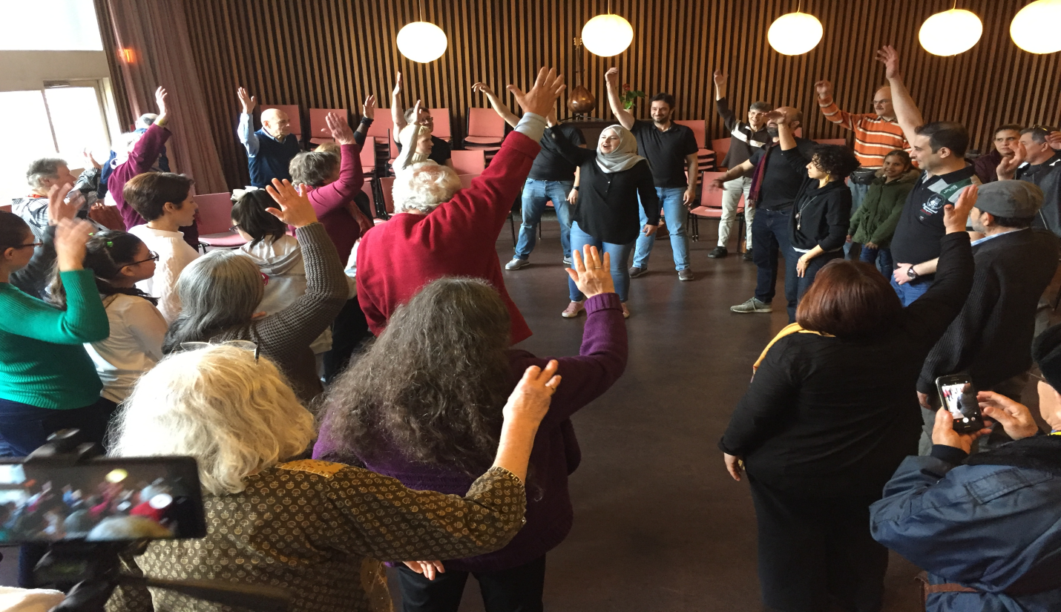

Home Away from Home-Refugee Rights Month Celebration

Thanks to the collaboration of Jobran Kanji, the Syrian Canadian Foundation and the
Arab Community Centre of Toronto, a special performance was held at the Quaker
House to celebrate Refugee Rights Month. It was a really delightful occasion, in which
the performers started with a difficult scenario, based on the lived experiences of the
participants. They shared the truth of their community’s experience with the audience.
We got a chance to participate in the performance, and try to find a resolution to the
problem we had just witnessed. It was a very good exercise for those in the audience to practice possibilities for change. We were impressed by a live music performance by a newly arrived refugee from Colombia. The occasion was also a really good opportunity for the Quaker Committee for Refugees to present a brooch designed by Nancy Pocock and engraved with thanks from QCR, as well as a book about stained glass by Sarah Hall to Nancy Ruth, a long time benefactor and friend of the QCR.

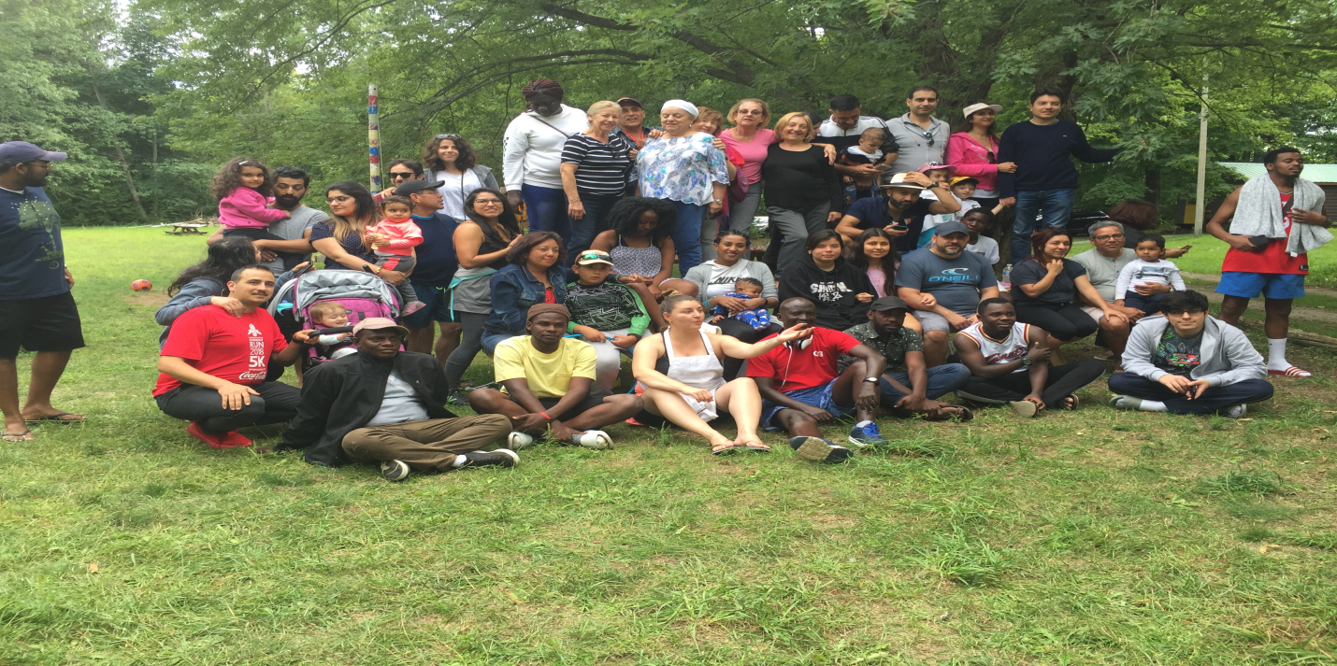
REFUGEE CAMP: LABOUR DAY WEEKEND 2019
This year's Labour Day Weekend Refugee Camp was once again a huge success. The
number attending was again impressively high, with everyone from young and older
singles to whole families, and with campers coming from four continents.

The statistics give some sense of the Camp's composition and success:
• number of campers - 79
• age range - 2 months to 71 years
• time in Canada - 2 days (a Syrian family of 3) to several years
• countries represented: Burundi, Chile, Colombia, Congo, El Salvador, Ethiopia, Eritrea, Gambia, Guatemala, Mexico, Nicaragua, Rwanda, Somalia, Sudan, Syria, Tanzania, Uganda and Venezuela

The composition of the camp showed some distinct patterns. Virtually all of the established campers (volunteers) were from Central America and it was their energy and organization that provided the camp with most of its organizational framework: they
arrived with cabin spaces already assigned; with menus laid out for the entire weekend;
with sign-up sheets for cooking and dish teams; and with a well thought out activity
schedule designed to engage all of the campers. Additionally, they offered examples
and mentorship to the newcomers, indicating that it was possible for all of them to
establish themselves in their new country. The newcomers included several young families from Syria, two temporarily single mothers from Africa, and numerous single, well- educated young adults, mostly men from north and east Africa.

Many thanks to our wonderful volunteers from the Salvadoran Canadian Association
(ASALCA) all the participants and special thanks to our Directors, Rae and Ken Mavor,
who gave so much of their time to make this camp a successful one. Our thanks also go to Camp NeKauNis Committee, and the individual donors who sponsored some of the new comers.
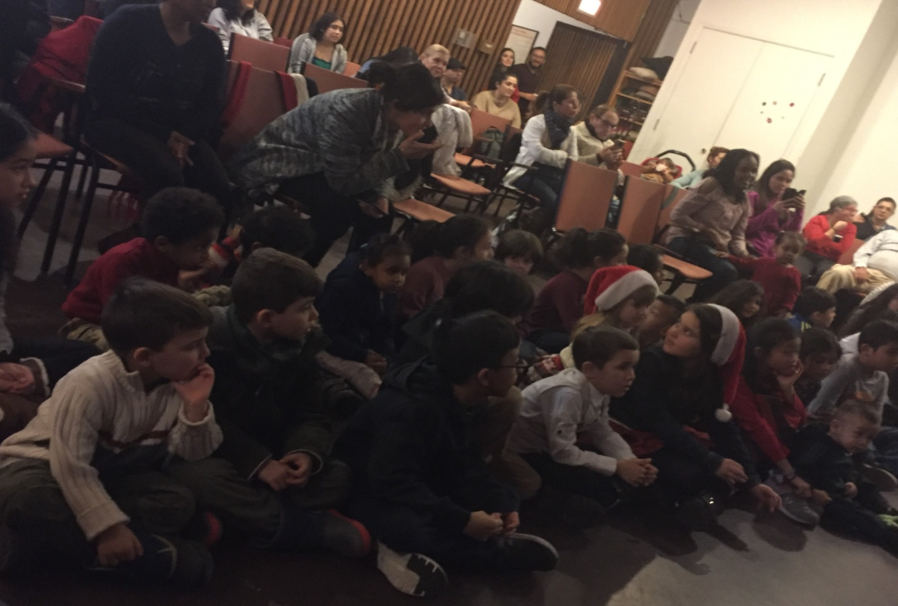

Christmas Children Party at the Quaker House

This special yearly event was a complete success. We received our financial assistance
and toys from CHUM on time. As usual we counted with an active engagement of
volunteers to do the toy wrapping, food, drinks distribution and almost full attendance
from families who had previously registered. There are always children who get sick due to the cold weather and parents asking if they could pick up their children’s toys the
following week. We were able to accommodate every request so every little one could
have a present before the holiday. We have lost count as to the number of years we have been able to hold a Christmas party but we are certain that for newcomers it is always a joy to be part of it. The children are thrilled to have a little something and we are left proud with fond memories of the occasion. We had great entertainment from Daniela Garcia, Elizabeth Block and the children themselves, delicious drinks and food and the special and well prepared traditional story of the little Jesus by Judy Pocock.

We are very thankful to CHUM Christmas Wish for their financial support and also for
their donation of more than a hundred toys. Many thanks to all the volunteers who made the event possible.

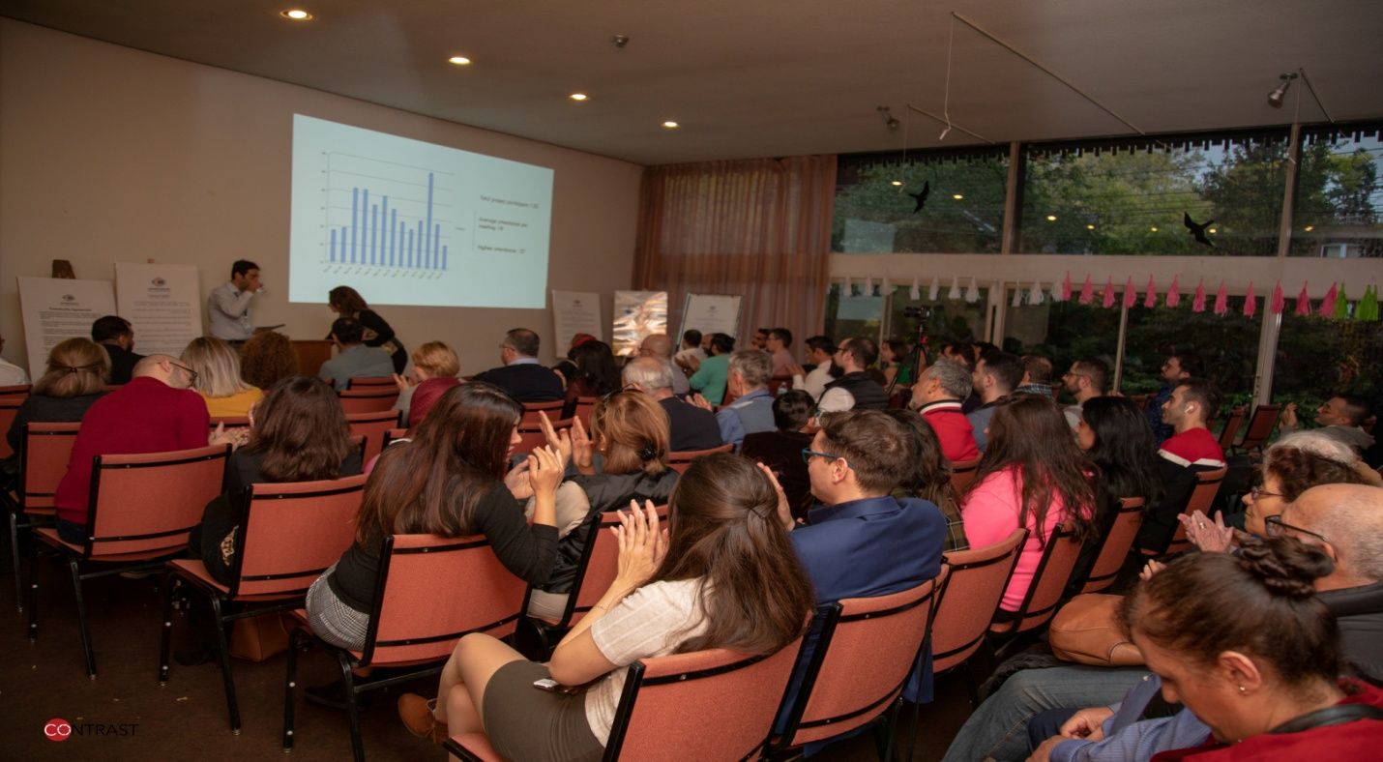

A New Initiative

Common Ground – Kaweh Wassat: is a nonpartisan, social and cultural, inclusive space that aims to create a warm environment, in which Syrian newcomers, Canadians of a Syrian heritage, and those who are interested in Syrian affairs and culture can come together to share coffee, food, memories, experiences, and opinions.
Common Ground – Kaweh Wassat aspires to contribute in promoting a culture of cooperation, convergence and dialogue through facilitating dialogue sessions, and cultural activities in which differences are employed to build bonds, rather than breaking them.
In Common Ground - Kaweh Wassat they get together twice a month on location of the Quaker House, to offer “ two cups of coffee”.

1) Cultural Cup (Second Sunday of every month): A gathering in which we discuss a topic of interest to the community. The gathering is concluded with a warm community dinner.

2) Social Cup (Forth Sunday of every month).The purpose of the gathering is to meet, connect, and offer entertainment in a fun atmosphere. Similar to the Cultural cup, the gathering is concluded with a community dinner.

Thank you

Through your financial and moral support in the past, you have played a role in keeping
the doors open to the refugee and immigrant community. We hope you understand how important your support is and that you will continue to be as generous as you have been over the years. We are very grateful to TMM for allowing the use of an office space and the house for our services and activities. We are also very grateful to the following organizations for their financial contribution:

Canadian Friends Service Committee (CFSC)
CHUM Charitable Foundation
Kitchener Area Monthly Meeting
Nancy’s Very Own Foundation
Samuel Rogers Memorial Trust
Anna Rita Kurtinis’ bequest
Many generous individuals.

Special thanks to Personnel Committee, Resident Friends, Ben Bootsma, Judith
Amundson and all the persons working in the house as substitutes, for supporting our
work in so many ways and to Secretary Asst. Treasurer Linda Stemmler for keeping
records and producing financial reports. They have really made Friends House a place where people feel a sense of belonging and benefit from a safe, healthy and positive surrounding environment.

All donations to the QCR are spent on the work of the committee, which is required to raise these funds to pay for all its expenses. As a concern of the TMM (Quakers), the Refugee Committee is a federally approved charitable organization (#11926-6955-RR0001). We welcome contributions, which may be made out to Toronto Monthly Meeting, with Quaker Committee for Refugees in the Memo line and mailed to: 60 Lowther Avenue, Toronto, Ontario, M5R 1C7.

Members of the refugee committee in 2019 were Brydon Gombay, Ebby Madera, Charlie Diamond, Eleanor Andrew, Frank Showler, Joe Kanji, John Gell, Judy Pocock, Raja Rajagopal, and Eusebio Garcia.

