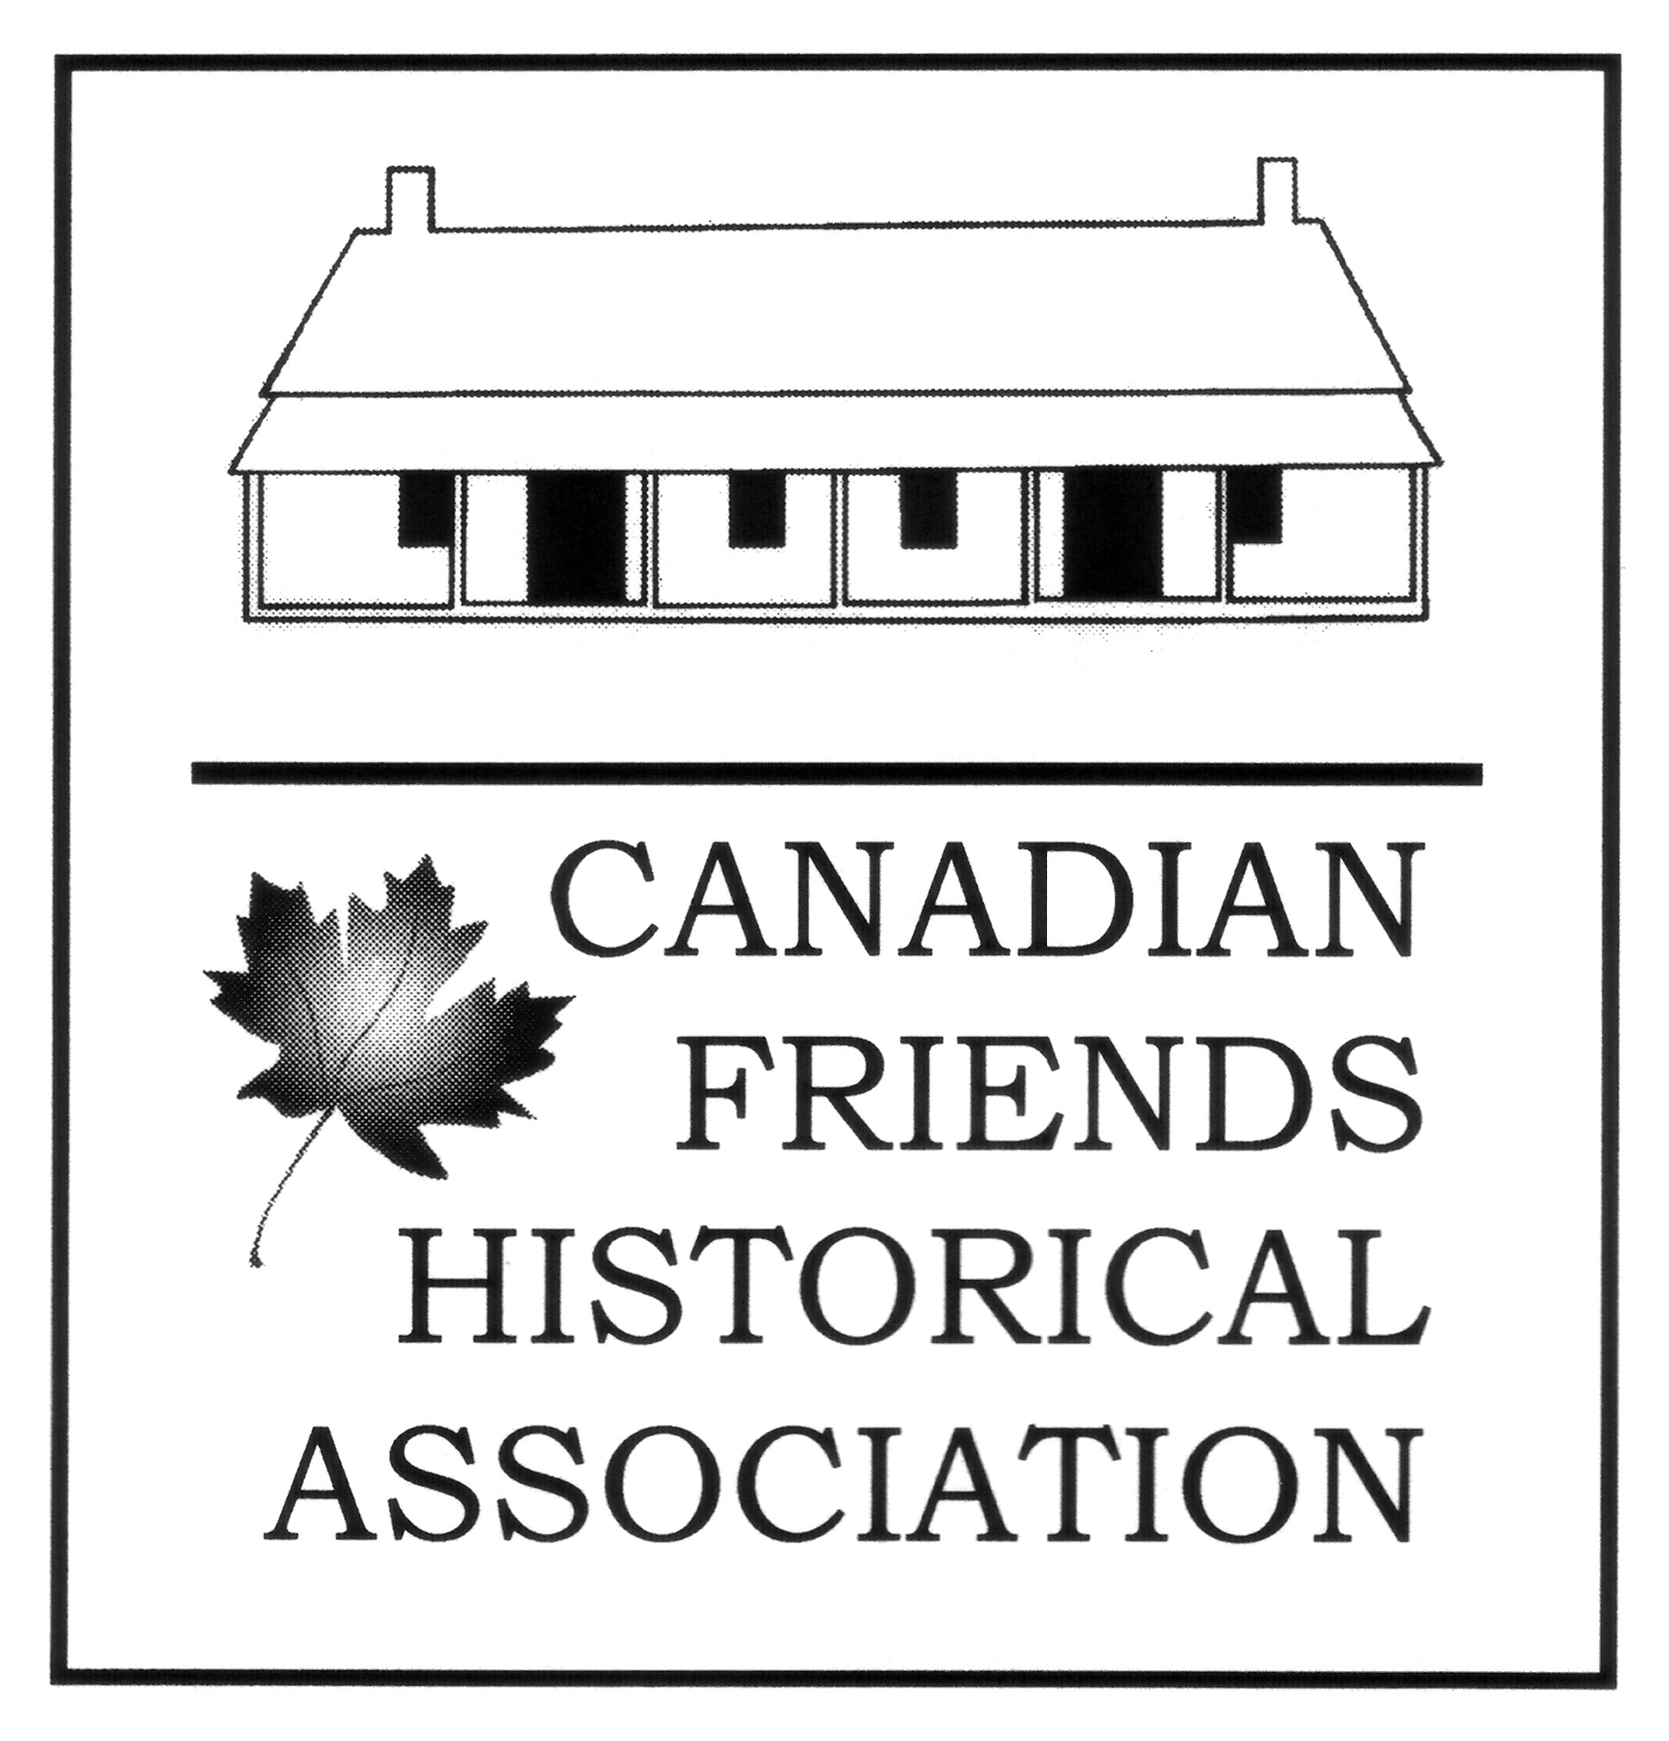
CANADIAN FRIENDS HISTORICAL ASSOCIATION
P.O. Box 21527, 17600 Yonge Street, Newmarket,
Ontario L3Y 4Z0 www.cfha.info

Black History Month Presentation

First Day, 2nd Month 17, 2019

Timothy Rogers Junior: Quaker to Slave Master
- An Extraordinary Account

a presentation by Randy Saylor of his recent exploration of the surprising details of the life of Timothy Rogers Junior. Timothy Rogers Junior (1788-1850) was the first-born child of Timothy Rogers senior, founder of the Quaker communities at Newmarket, Pickering and Uxbridge. He found himself unable to adhere to the Quaker principles instilled in him as he matured in Upper Canada. Randy details the experience and consequences of his adult life as an early 19th century Virginia slave owner. An impressive trove of Canadian and American documents reveals how the vocation of the son affected Timothy Rogers senior and his second wife Anna in Upper Canada. Most significantly, the presentation will focus on and discuss the astonishing and unexpected outcomes which arise when, at the end of his life, Timothy Rogers Junior seeks to emancipate the slaves in his possession. What ensues upon his death in 1850 provides a richly detailed insight into the nature of slavery at the time, and the remarkable stature of individual slaves as they reveal themselves in the historic record. Prepare to be informed and surprised.

The presentation is excepted to last approximately an hour with a break for light refreshments and a Question and Answer period to follow. The presentation is open to members and attenders of TMM and CFHA and the public. Admission is free, goodwill donations accepted. Contact Gordon Thompson 905-471-9528 if you have questions.

Venue: Friends House, 60 Lowther Avenue, Toronto, Ontario M5R 1C7
,\\
Time: 1:00 PM in the Main Meeting Room

Sponsored by Canadian Friends Historical Association and Toronto Monthly Meeting of the Religious Society of Friends

The Mission of the Canadian Friends Historical Association is the preservation and communication of the on-going history and faith of the Religious Society of Friends (Quakers) in Canada and their contribution to the Canadian Experience.

The Canadian Friends Historical Association is an Ontario Corporation and a Canadian Registered Charity.

